**Web Application Case Study**

**System Name:** E-commerce Front-end Application

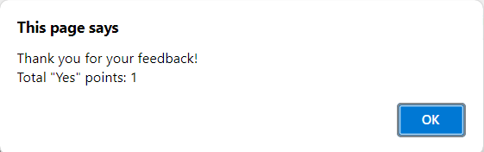**Used Tool:** HTML, CSS and JavaScript

**System Navigation Flow:**

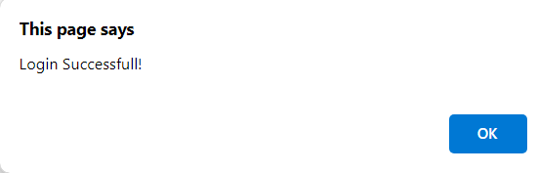

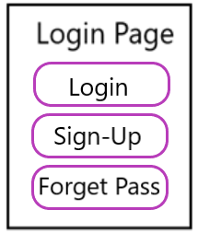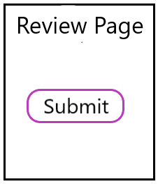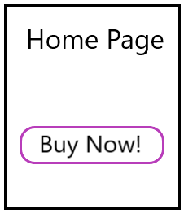

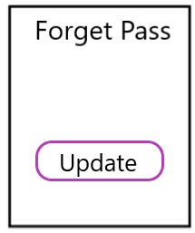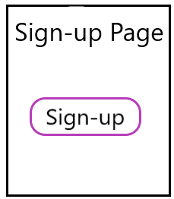

1. In the “Home Page”, user can browse products in the application. There are four categories each category has two products per page. If the user clicked on “Buy Now”, the system will navigate to the “login page”.
2. In the “Login Page” user has two options:

* If he has an exist account >> Insert username & password and click on “Login” button.
* If he has no account >> Click on “Sign-Up” button.

1. In the “Sign-Up” page, the user inserts all of required information and click on “Sign-Up” button. Then, the “Sign-Up” button will redirect to “Login Page” and the user is asked for enter his username & password.
2. If the user clicked on “Login” button, he has two options:

* 1st: Login Successful >> the system will show “login successful” message and the “Review page”.
* 2nd: Login Failed >> the system will show an error message and redirect to “Login Page” again.

1. In the “Review Page”, the user is asked to answer all feedback questions (5 questions) and click on “Submit” button. Then, the system will show a message of the user feedback and redirect to the “Home Page”.

**Login Database:** Create only one array of objects that has the following attributes:

* User (Username, Password, Age, Gender, Phone number)
* **Notice that:** username is a unique value
* **Example:** You are **FREE** in selecting the appropriate data structure.

let login_Users = [

{

username: "user1", pass: "pass123", age: 25, gender: "male", phone: "123-456-7890"

},

{

username: "user2", pass: "abc456", age: 30, gender: "female", phone: "987-654-3210"

}

];

**CSS Properties: FEEL FREE** in your styling but using following properties in CSS is a **must.**

|  |
| --- |
| 1. Border  2. Margin  3. Font family  4. Font size  5. Font color  6. Background  7. Display-flex  8. Align-items  9. Position  10. Height  11. Width  12. Paddings  13. Justify-content  14. Opacity  15. Text decoration |

**System Description:**

1. **Home Page:**

**This page is composed of four parts:**

* Header: name of web application
* Navigation bar: navigate from category to another using slider.
* Body: each category has two products in distinct div **is a must**.
* Footer: write branches, contact and accounts information.
* Showing header, Navigation bar, Body and Footer **is a must.**
* You are **FREE** in applying **Slider** it by Html, CSS or JavaScript.

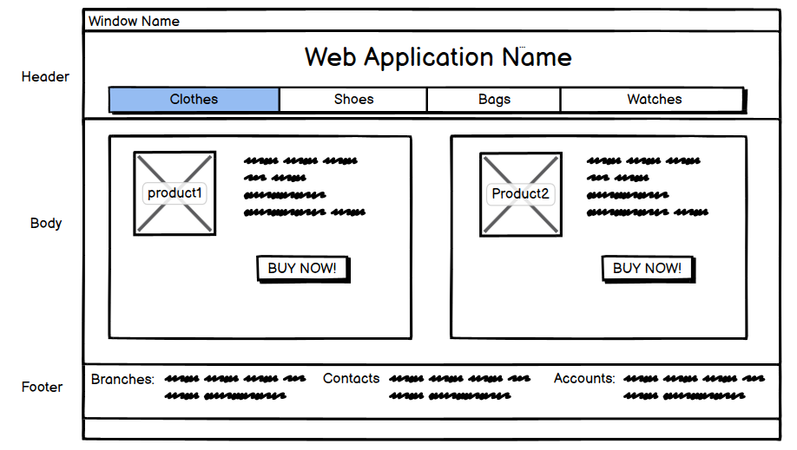

**Note: You need to build all of “Login”, “Sign-Up” and “Forget-password” forms in ONE PAGE.**

1. **Login Form:**

**This page is composed of:**

* two textboxes
* two labels
* “Login” button
* “Submit” button
* “Sign-Up” button

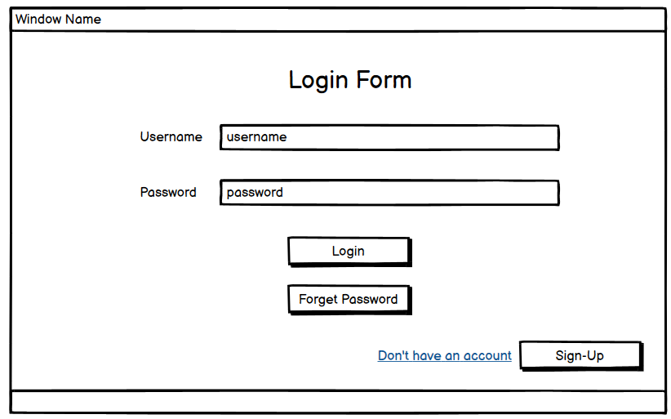

1. **Forget Password Form:**

**This page is composed of:**

* two textboxes
* two labels
* “Update” button

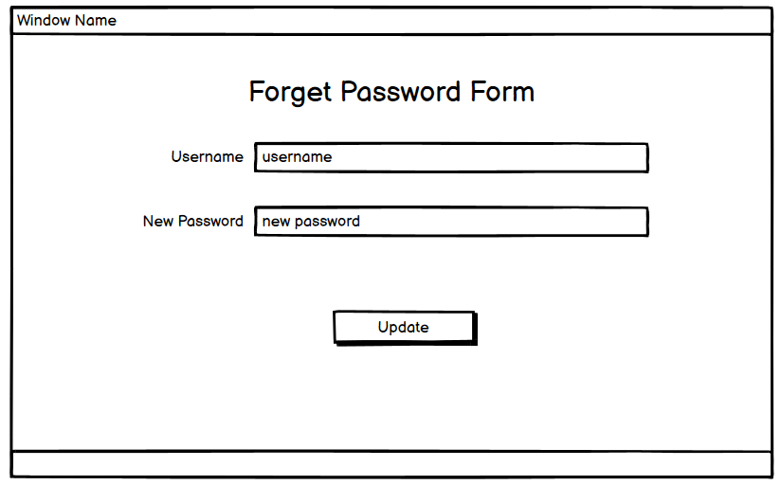

1. **Sign-Up Form: This page user has to enter** Username, Password, Age, Gender, Phone number and City.

**This page is composed of:**

* Five textboxes
* Five labels
* “Submit” button
* **Validation Condition is a must:** Phone Number is 11, Gender is male or female, Password composed of char and integers and less than 8 characters and Age is in between 18 and 60.

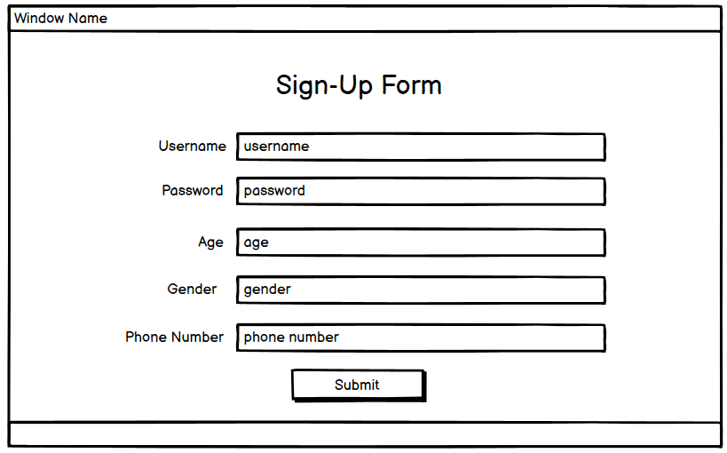

1. **Review Page:**

**This page is composed from:** using **Table** in this form is a **must**

* Three questions: showed in the below screenshot.
* Three pairs of radio buttons
* “Submit button”
* Showing the “Review Result” in Alert Message is a **must.**



